EXPT NO: 10 | BUILDING A SIMPLE LLM CHATBOT USING STREAMLIT/GRADIO
DATE: 12.10.2026 | BUILDING A SIMPLE LLM CHATBOT USING STREAMLIT/GRADIO

PRE-LAB QUESTIONS (PROVIDE BRIEF ANSWERS TO THE FOLLOWING QUESTIONS)

- What is a Large Language Model (LLM)?
A Large Language Model (LLM) is an artificial intelligence model trained on a large amount of text data to understand and generate human language. It can perform tasks such as answering questions, summarizing documents, translating languages, generating code, and participating in conversations. LLMs learn patterns, grammar, and relationships between words during training. Modern LLMs commonly use Transformer-based architectures to process text efficiently. Examples include GPT and models available through Hugging Face Transformers. In this experiment, an LLM is used to generate responses to user prompts and provide the main functionality of a chatbot.

- What is the role of the Transformer architecture in modern LLMs?
The Transformer architecture is a deep learning architecture widely used in modern Large Language Models. Its main feature is the attention mechanism, which helps the model identify relationships between different words or tokens in a sequence. Unlike traditional sequential models, Transformers can process many tokens in parallel during training, improving computational efficiency. Self-attention enables the model to consider relevant context when interpreting language and generating responses. Transformer models are trained on large datasets to learn language patterns. In this experiment, a Transformer-based model processes user prompts and generates meaningful text responses for the chatbot.

- What is a prompt, and how does it influence an LLM's response?
A prompt is the text, question, instruction, or information provided by a user to a Large Language Model to obtain a response. It guides the model regarding the task to perform and the type of information to generate. A clear and specific prompt generally produces a more relevant and useful response than a vague prompt. For example, asking the model to explain a concept in simple language helps determine the style and level of detail of the answer. The response can also depend on the prompt's context, wording, and instructions. In this experiment, prompts are entered through the chatbot interface and processed by the selected LLM.

- What is the difference between a chatbot and a conventional rule-based program?
A chatbot powered by a Large Language Model generates responses by using patterns learned during training and the context provided in the conversation. It can handle different questions and natural-language instructions without requiring a separate predefined rule for every possible input. In contrast, a conventional rule-based program follows explicitly programmed conditions, rules, and decision paths. Its responses are generally limited to the situations covered by those rules. LLM-based chatbots are more flexible in conversational tasks, but they can produce inaccurate or unexpected answers. Rule-based programs are often more predictable for narrowly defined tasks. Both approaches are useful depending on the application requirements.

- What are Streamlit and Gradio used for?
Streamlit and Gradio are Python frameworks used to create interactive web interfaces for machine learning applications. They allow developers to build user-friendly applications without needing extensive knowledge of HTML, CSS, or JavaScript. Streamlit is useful for creating data-driven applications with text inputs, buttons, charts, and other interactive components. Gradio provides convenient components for demonstrating machine learning models through inputs and outputs, including chatbot interfaces. In this experiment, either framework can provide a text box or chat input for entering prompts and displaying the LLM's responses. They also help developers test, demonstrate, and share chatbot applications locally or through supported hosting platforms.

AIM
To build a simple chatbot or AI application using a Transformer-based Large Language Model (LLM), process user prompts, generate responses, and deploy the application using Streamlit or Gradio.

SOFTWARE REQUIREMENTS
- Python
- Google Colab / Jupyter Notebook / Local Python environment
- Hugging Face Transformers
- PyTorch (or another supported model backend)
- Streamlit or Gradio
- GitHub (for version control and submission)
- A web browser
- An LLM API key, if using a hosted model API

OBJECTIVES
Students will be able to:
- Understand the basic working of Transformer-based LLMs.
- Select and load a suitable pretrained language model or connect to a hosted LLM API.
- Accept user input through a prompt-based interface.
- Generate and display responses from the selected model.
- Build a simple chatbot interface using Streamlit or Gradio.
- Maintain conversation history where supported.
- Test the chatbot with different prompts and evaluate the relevance of its responses.
- Run and demonstrate the deployed application.

PROCEDURE
PART A: ENVIRONMENT SETUP AND MODEL SELECTION
Perform the following tasks:
- Create a Python notebook or project folder.
- Install the required libraries, such as transformers, torch, and either Streamlit or Gradio.
- Choose a suitable pretrained instruction-following or conversational model or select a hosted LLM API.
- Read the model documentation and check its hardware, memory, access, and usage requirements.
- Load the model and tokenizer or configure the API client and store the API key securely as an environment variable.
- Test the setup with one simple input prompt.
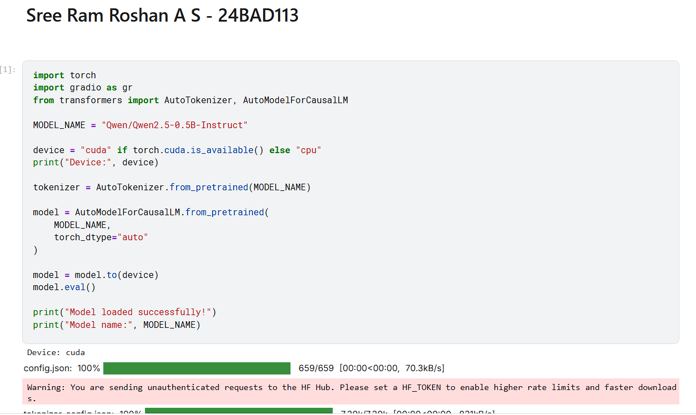
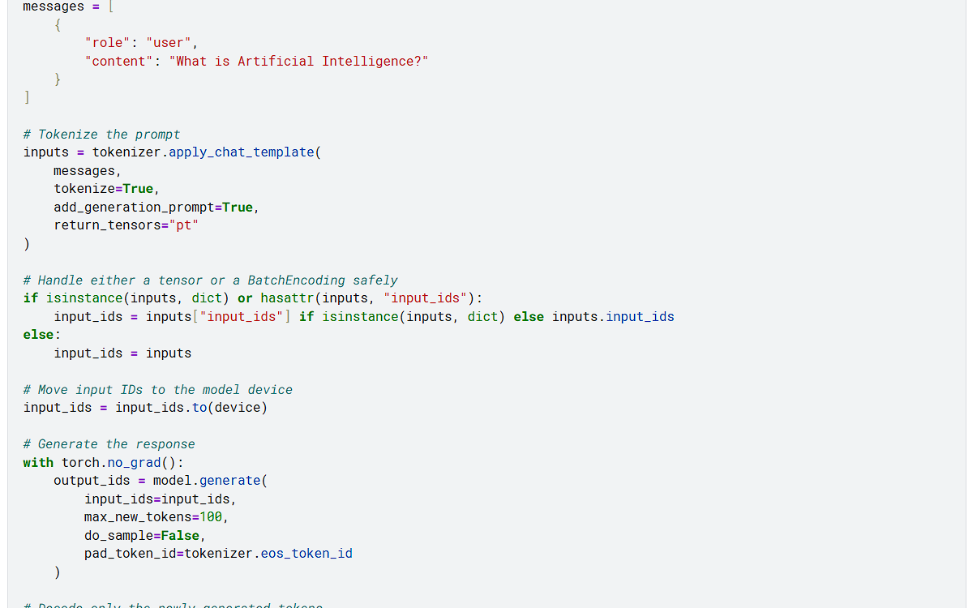
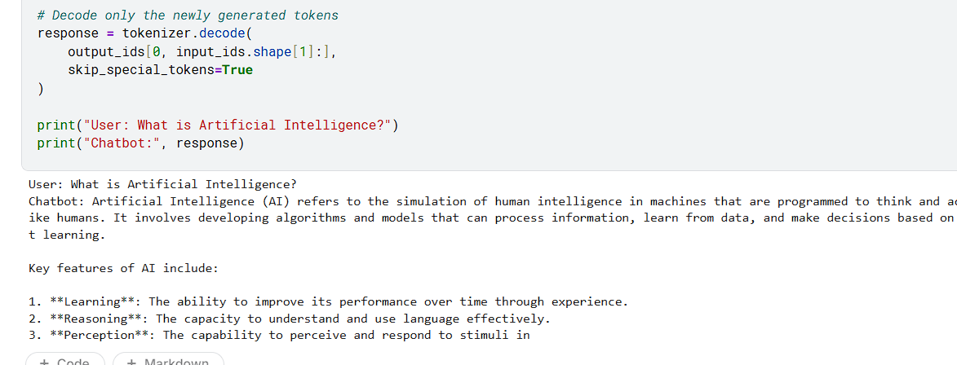

PART B: PROMPT HANDLING AND RESPONSE GENERATION
Perform the following tasks:
- Define a function that accepts a user message as input.
- Prepare the prompt in the format required by the selected model or API.
- Pass the prompt to the model and generate a response using suitable generation settings.
- Decode and display the generated response clearly.
- Handle empty input and basic runtime or API errors.
- Test the function using at least five different prompts and record the responses.

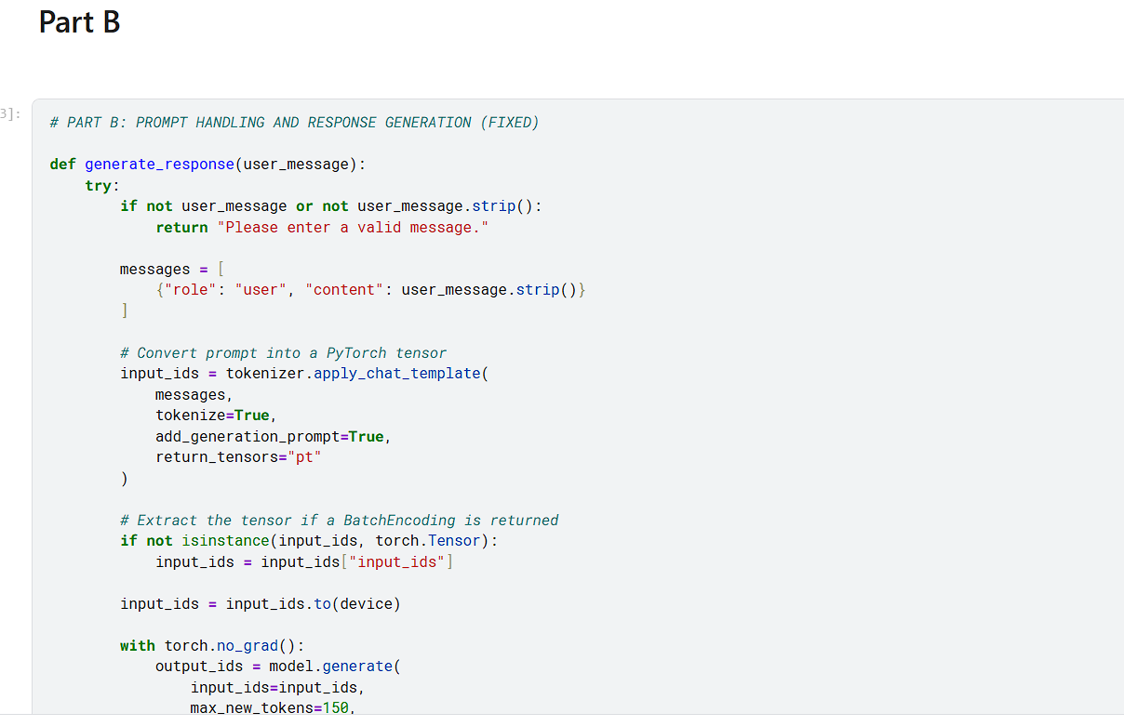
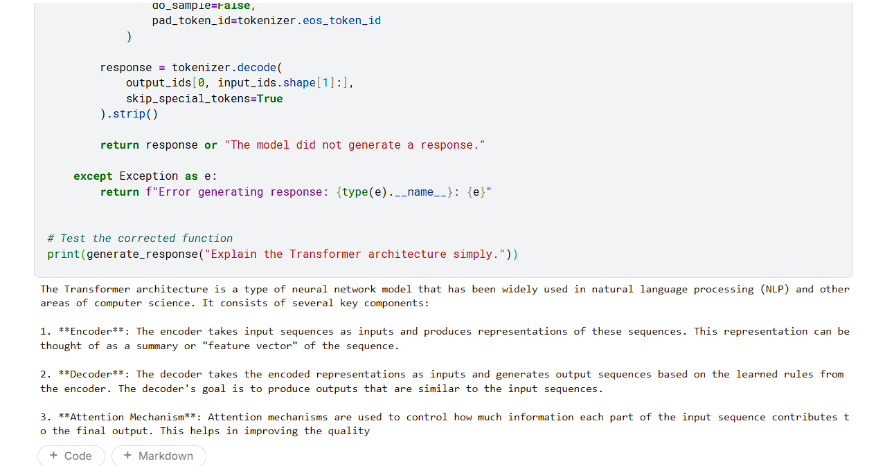
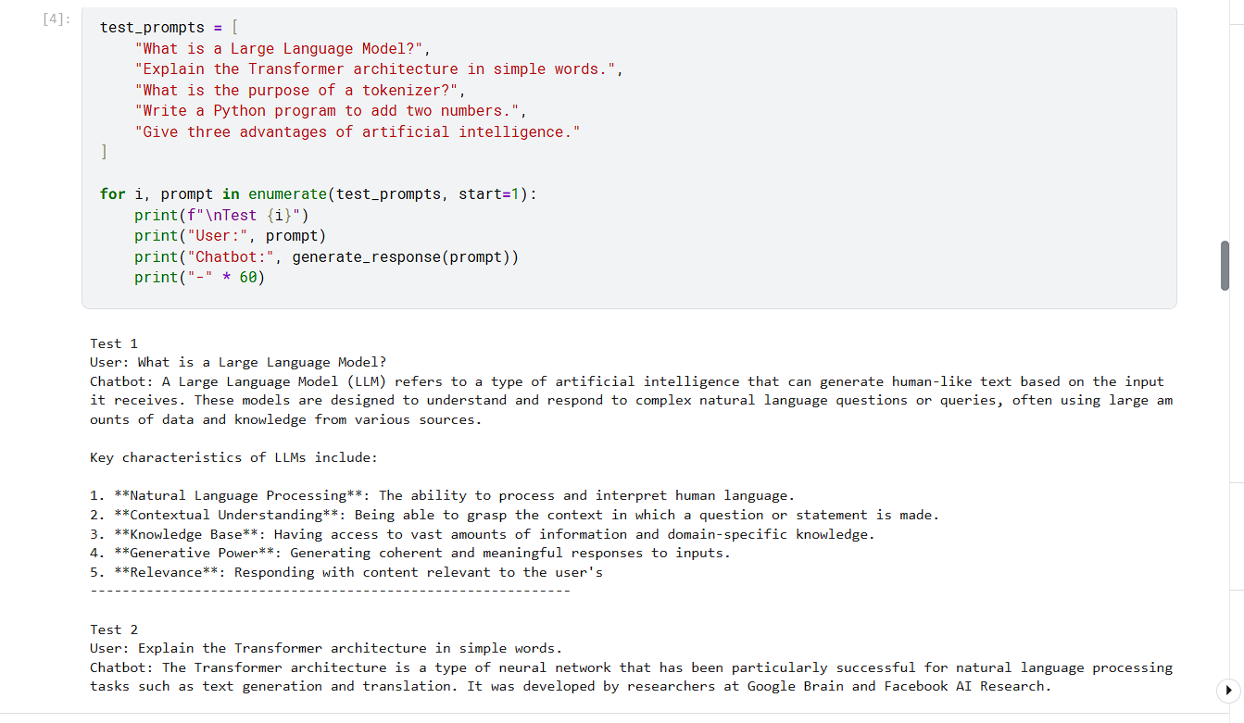
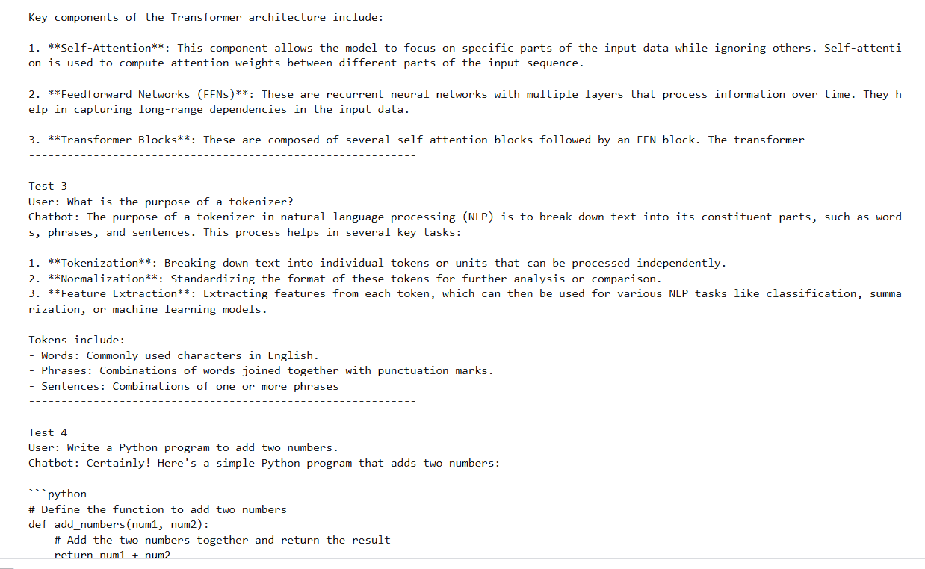
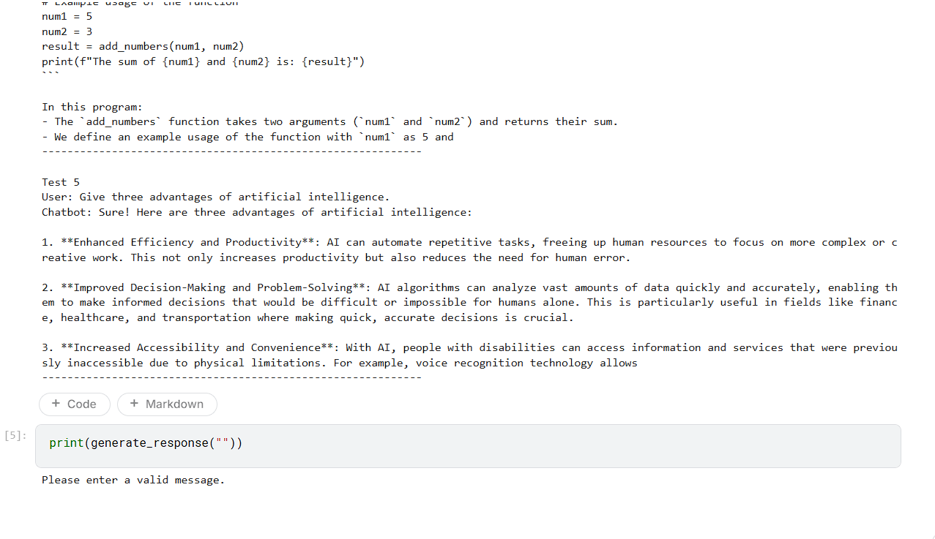

PART C: BUILDING THE CHATBOT INTERFACE
Perform the following tasks:
- Choose either Streamlit or Gradio to create the user interface.
- Add a text box or chat input for entering user messages.
- Display the user message and the model-generated response in the interface.
- Maintain conversation history if supported by the selected model and interface.
- Add a clear-chat or reset option if appropriate.
- Run the application locally and test the interaction from a web browser.

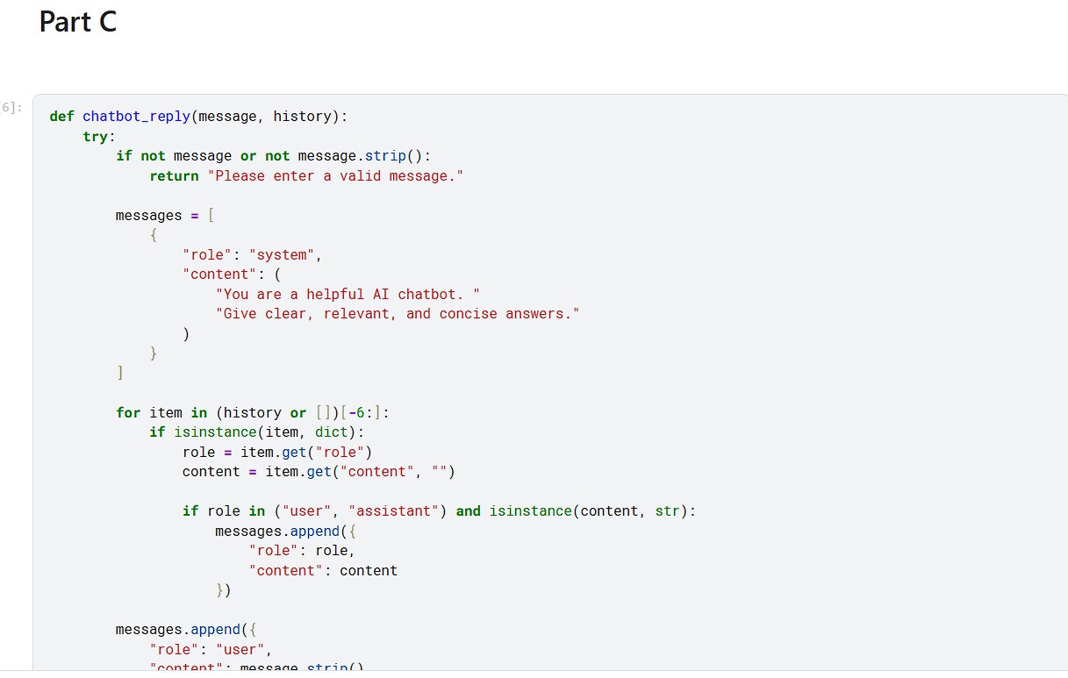
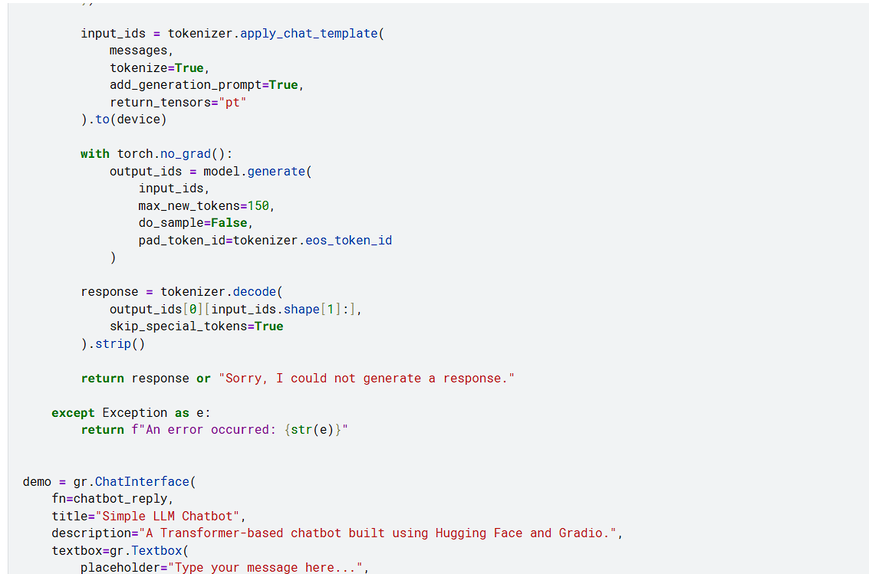
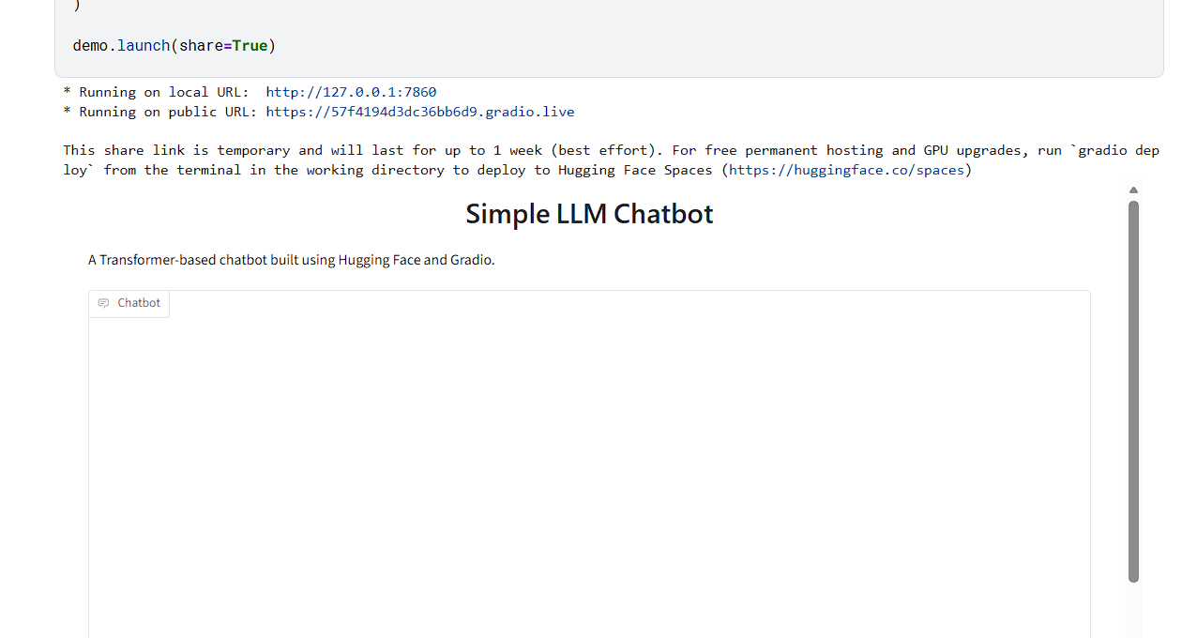

PART D: TESTING AND DEPLOYMENT
Perform the following tasks:
- Test the chatbot with factual, conversational, and task-oriented prompts.
- Check whether the responses are relevant, readable, and consistent with the prompts.
- Identify any incorrect, biased, or unsafe responses and note the limitations.
- Deploy the application using an available hosting option supported by Streamlit or Gradio or demonstrate it locally if deployment access is unavailable.
- Do not upload API keys or other secrets to GitHub; use environment variables or the hosting platform's secrets settings.
- Save the source code, requirements file, screenshots of the interface, and sample outputs.
- Include the GitHub repository link and the application link, if publicly deployed, in the submission.

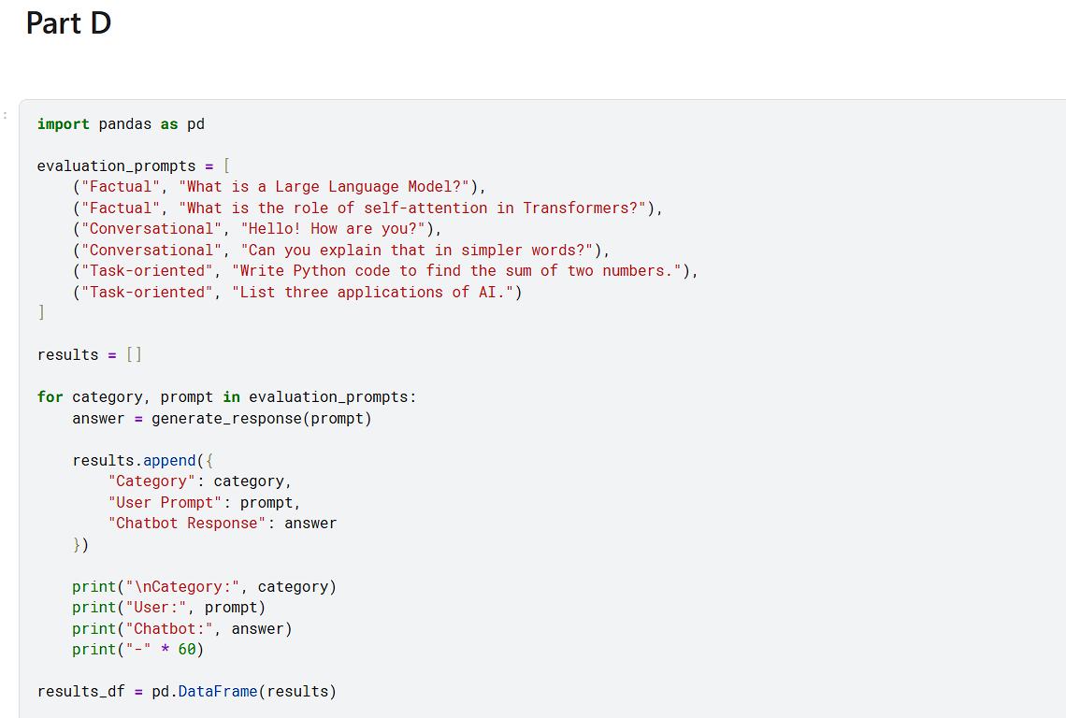
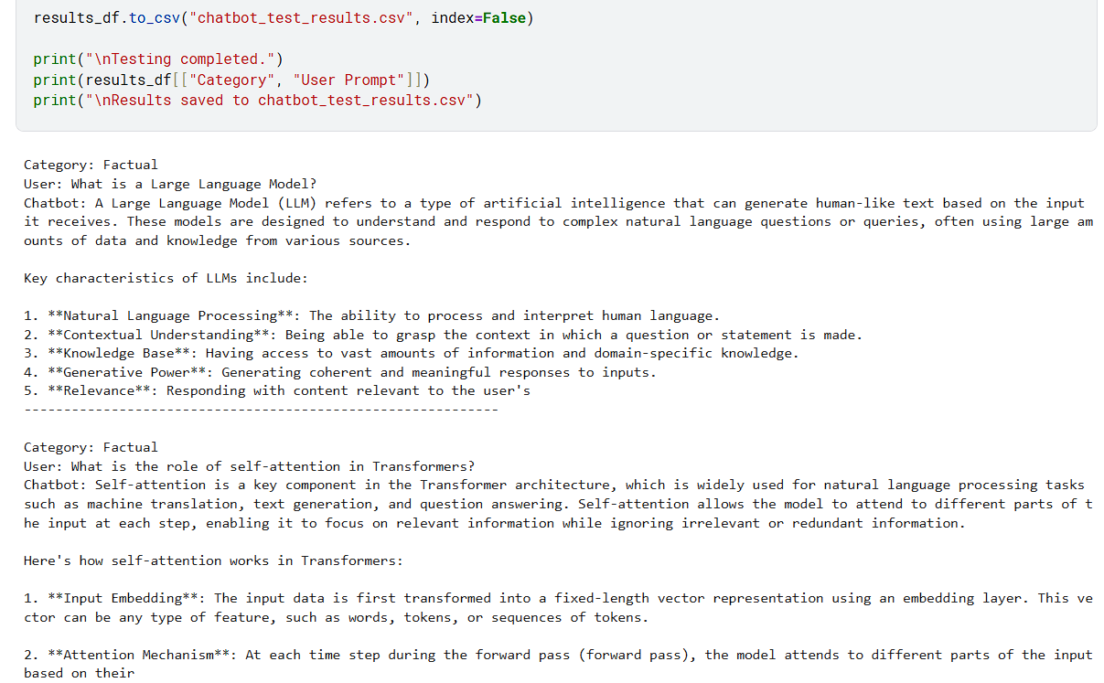
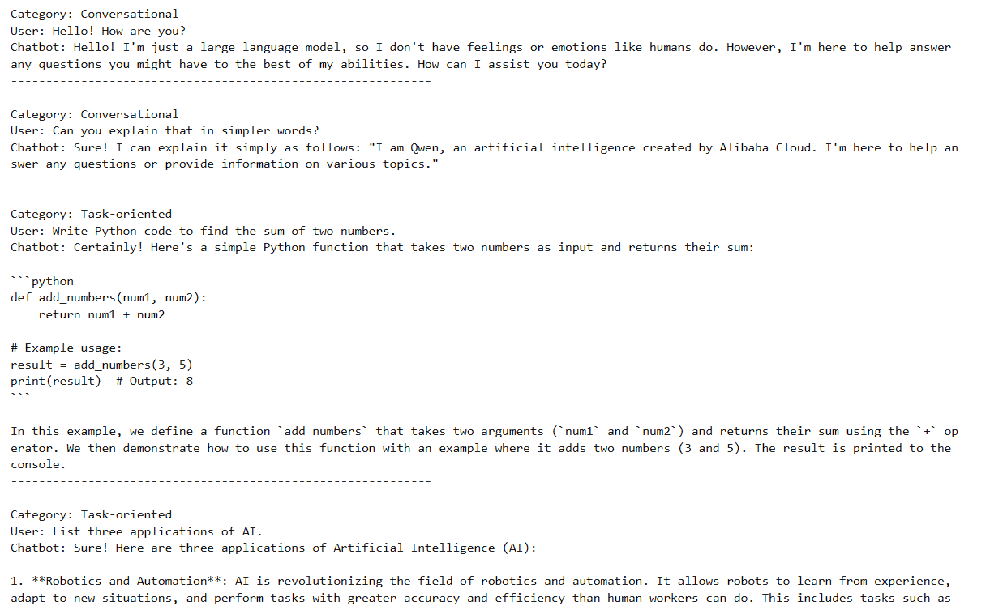
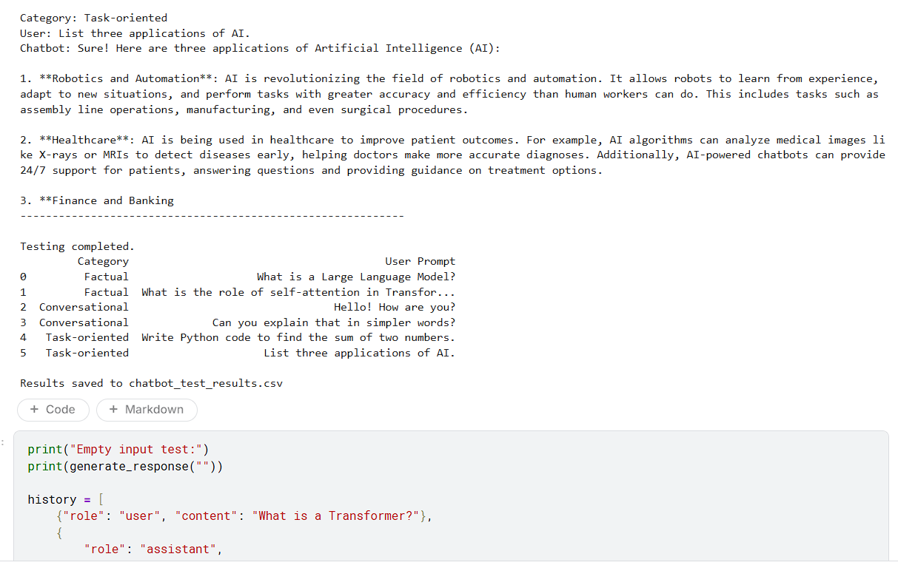
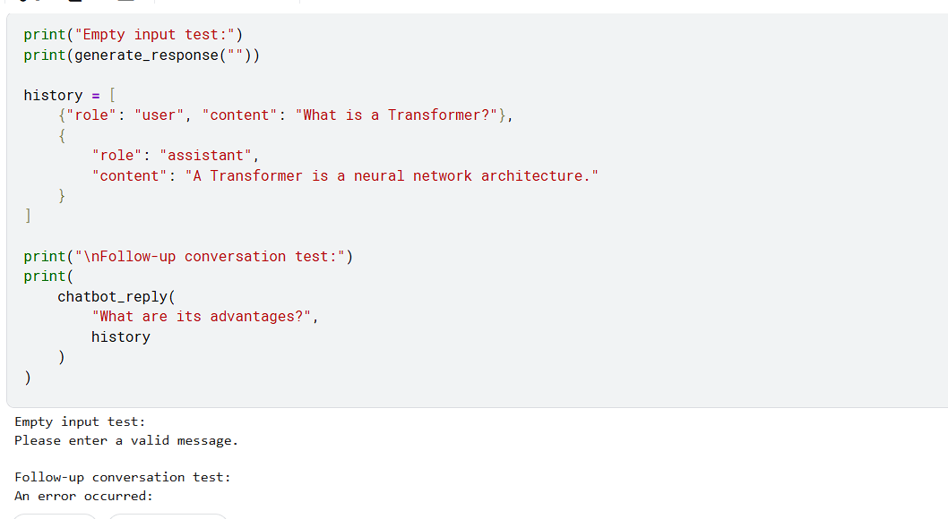
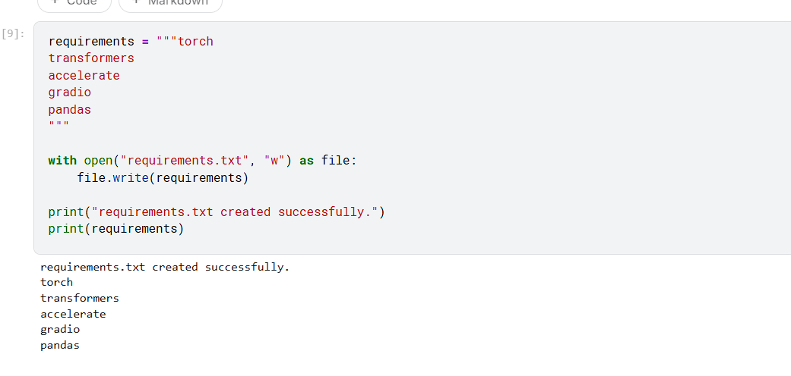

EXPECTED OUTCOME
Students will understand the basic use of Transformer-based LLMs for prompt-based text generation and chatbot development. They will build a working chatbot interface using Streamlit or Gradio, test its responses with different prompts, and run or deploy the application. Students will also identify limitations such as inaccurate responses, model-access requirements, latency, and responsible handling of user inputs and API credentials.

POST-LAB QUESTIONS (PROVIDE BRIEF ANSWERS TO THE FOLLOWING QUESTIONS)

- What is the function of a tokenizer in an LLM application?
A tokenizer converts input text into smaller units called tokens, which may represent words, parts of words, punctuation marks, or other text elements. The tokenizer maps these tokens to numerical identifiers that the language model can process. Before generating a response, the input prompt is tokenized into a suitable sequence of token IDs. After generation, the output token IDs are converted back into readable text through decoding. Tokenization is important because LLMs operate on numerical representations rather than directly processing ordinary text. In this experiment, the tokenizer prepares user prompts for the selected pretrained model and helps convert the generated output into a readable chatbot response.

- How does a Transformer-based LLM generate a response to a prompt?
A Transformer-based LLM generates a response by first receiving the user's prompt and converting it into tokens. These tokens are transformed into numerical representations and processed through the model's neural network layers. The self-attention mechanism helps the model use contextual information from the input sequence. The model then predicts the probability of possible next tokens and selects tokens according to its generation strategy and settings. This process continues until a stopping condition is reached, such as an end-of-sequence token or a maximum token limit. Finally, the generated tokens are decoded into readable text and displayed to the user through the chatbot interface.

- What is the purpose of Streamlit or Gradio in this experiment?
Streamlit or Gradio is used to create the interactive user interface for the LLM chatbot. The framework allows users to enter questions or instructions through a text box or chat input and view the responses generated by the language model. It connects the model's processing function with a convenient interface, making the application easier to use and demonstrate. Depending on the implementation, the interface can also maintain conversation history, provide a reset button, and display errors when something goes wrong. In this experiment, Streamlit or Gradio helps transform the underlying Python model code into a practical chatbot application that can be tested through a web browser.

- Why should an API key be stored securely and not committed to GitHub?
An API key is a secret credential that allows an application to access a hosted service, such as a language model API. If the key is uploaded publicly to GitHub, unauthorized users may copy and misuse it, potentially causing unexpected charges, exhausting usage limits, or accessing services under the owner's account. Therefore, API keys should be stored securely using environment variables or the hosting platform's secrets-management settings. They should not be written directly into source code or committed to a public repository. If a key is accidentally exposed, it should be revoked or rotated promptly. Secure credential management protects the application, the user's account, and associated resources.

- What is conversation history, and how can it improve a chatbot?
Conversation history is the record of previous messages exchanged between a user and a chatbot, including user prompts and the model's responses. When this history is included in later prompts, the model can use earlier information to understand references, follow-up questions, and the context of an ongoing discussion. For example, if a user asks a chatbot to explain a Transformer and then asks about its advantages, conversation history helps the model understand what the word refers to. This can make the interaction more natural and consistent. However, the history must be managed carefully because long conversations consume tokens and may exceed the model's context limit.

- Mention two limitations of LLM-based chatbots.
Two important limitations of LLM-based chatbots are inaccurate responses and computational or operational requirements. First, an LLM may generate incorrect information or plausible-sounding statements that are not supported by facts. Therefore, important answers should be checked against reliable sources. Second, running a large model can require substantial memory, processing power, and time, while using a hosted API may involve network latency, access restrictions, or usage charges. Other limitations include biased outputs, privacy concerns, and difficulty maintaining consistency across long conversations. In this experiment, testing the chatbot with different prompts helps identify some of these limitations and evaluate the quality of its responses.

- How can you test whether a chatbot's responses are relevant?
A chatbot's response relevance can be tested by providing different types of prompts, such as factual questions, conversational messages, and task-oriented instructions. The generated responses should be compared with the original prompts to determine whether they answer the intended questions and follow the given instructions. Testing should also examine factual correctness, clarity, completeness, consistency, and readability. For example, a prompt asking for three advantages of Transformers should produce three relevant advantages rather than unrelated information. Testing with ambiguous, empty, and follow-up inputs can reveal additional weaknesses. Recording sample prompts and outputs makes evaluation easier and helps identify cases where the model needs improvement.

- What is the difference between running an application locally and deploying it online?
Running an application locally means executing it on a personal computer or local development environment, such as Jupyter Notebook, a terminal, or a local Streamlit or Gradio server. It is mainly useful for development, debugging, and testing, and access is generally limited to the local machine or configured local network. Deploying an application online means hosting it on a server or supported cloud platform so that users can access it through a network URL. Online deployment may require configuration of dependencies, environment variables, secrets, and resource limits. Local execution is convenient for development, while online deployment makes the chatbot easier to share and demonstrate to other users.

SUGGESTIONS FOR DATASETS
- Hugging Face Transformers documentation – https://huggingface.co/docs/transformers/index
- Hugging Face conversational / text-generation models – https://huggingface.co/models?pipeline_tag=text-generation
- Streamlit documentation – https://docs.streamlit.io/
- Gradio documentation – https://www.gradio.app/docs

ASSESSMENT
Description | Max Marks | Marks Awarded
Pre Lab Exercise | 5
In Lab Exercise | 10
Post Lab Exercise | 5
Viva | 10
Total | 30
Faculty Signature

